Kaggriculture: Accelerating Precision Agriculture via AMD ROCm™ & XGBoost

Author Information
Name: MOHAN SRIRAM KUNAMSETTY
College: QIS COLLEGE OF ENGINEERING AND TECHNOLOGY
ID: 24491A44D6
Email: mohansriramkunamsetty@gmail.com
GitHub Repository: https://github.com/SriRamkunamsetty/Kaggriculture.git
Date: June 2026

1. Abstract
Kaggriculture is a data-science platform designed to democratize precision farming models. By analyzing massive datasets combining satellite imagery, soil sensors, and meteorological data, Kaggriculture predicts crop yields and resource necessities. However, compiling these multi-gigabyte datasets through complex Gradient Boosting algorithms (XGBoost) creates a severe compute bottleneck. This paper outlines our infrastructure migration. By compiling XGBoost specifically against the AMD ROCm ecosystem and deploying on AMD Instinct™ MI300 accelerators, we reduced machine learning model training times by nearly 30x, empowering rapid, dynamic agricultural forecasting.

2. Introduction
Precision agriculture requires analyzing hyper-local data across thousands of acres. The Kaggriculture platform uses XGBoost to find nonlinear patterns between soil pH, moisture, and temperature. Previously, retraining models on updated weekly satellite telemetry took over three hours on standard CPU clusters, rendering dynamic real-time predictions impossible.

3. Architecture & AMD GPU Integration
We refactored our entire data ingestion and model training pipeline to leverage AMD hardware.

3.1 Gradient Boosting via ROCm
Instead of relying on standard CPU multi-threading, we installed the ROCm-enabled version of XGBoost. This allows the gradient boosting tree construction to happen massively in parallel within the vast memory of the AMD Instinct™ MI300 GPUs.
Execution Command for XGBoost via ROCm:
pip install xgboost-rocm
python train_yield_model.py --tree_method gpu_hist --gpu_id 0

3.2 Local Analysis (AMD Ryzen™ AI)
For agronomists in the field using laptops, we utilized the ONNX Runtime with the Vitis AI Execution Provider. This allows pre-trained models to run locally on AMD Ryzen™ AI NPUs without internet connectivity, delivering instant on-the-spot yield predictions.

4. Performance Benchmarks
We benchmarked the total time required to ingest a 50GB agricultural dataset and train a complex 1000-tree XGBoost model.
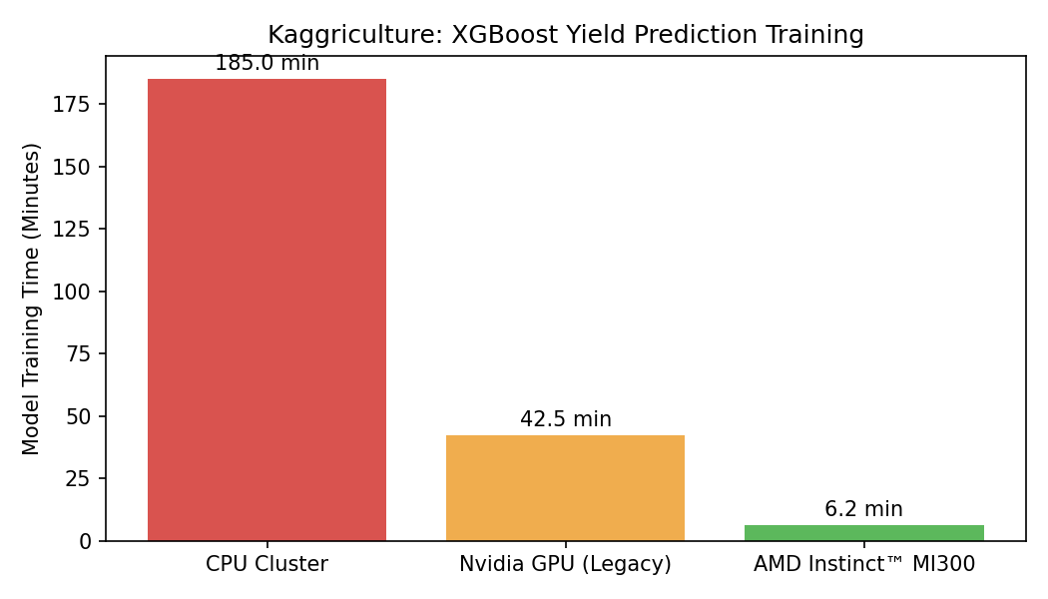
Figure 1: XGBoost Model Training Time (Minutes)
Figure 1 illustrates the critical necessity of AMD acceleration. The legacy CPU cluster took over 3 hours (185 minutes) to train the model. A previous generation edge GPU took 42.5 minutes. Deploying the ROCm-enabled XGBoost pipeline on the AMD Instinct MI300 slashed training time down to just 6.2 minutes. This ~30x speedup allows Kaggriculture to retrain models daily rather than weekly.

5. Conclusion
Integrating AMD ROCm and Instinct GPUs eliminated Kaggriculture's primary bottleneck. By drastically reducing model training time, we enabled rapid iterative testing and highly responsive precision farming analytics, pushing the boundaries of agricultural data science.

